

# DIPLOMA IN COMPUTER SCIENCE SCHOOL OF COMPUTING

**Assessment: Individual Project**

|  |  |
| --- | --- |
| **Course Code:** | **DCS3003** |
| **Course Name:** | **WEBSITE DESIGN** |
| **Academic Session:** | **September - December 2024** |
| **Lecturer’s Name:** | **Ms Teo Choon Yeh** |

|  |  |
| --- | --- |
| **Release Date:** | **6th September 2024** |
| **Submission Due Date:** | **17th November 2024** |

|  |  |  |  |
| --- | --- | --- | --- |
| **Weightage (%):** | **20** | **Marks Obtained:** | **20** |

## Student’s Declaration

I certify that this project is my own work, and appropriately acknowledged wherever material adapted from other sources. I understand that plagiarism, cheating, collusion, fraud, fabrication or falsifications of data are not acceptable. I agree that if at any time it is shown that I have significantly misrepresented material submitted to Crescendo International College, any marks or credits awarded to me on the basis of that material may be revoked.

|  |  |  |  |
| --- | --- | --- | --- |
| Student Name | Ng Jun Heng | Student ID | MCDCS2401031 |
| Signature |  | Date | 15-11-2024 |

## Project Description

1. **Project Title:** Website Design – Project (**Your Website Name**)

## Course Learning Outcomes Covered

|  |  |
| --- | --- |
| CLO1 | Explain website development practically based on design requirements (C2, PLO2) |
| CLO2 | Manipulate with guidance a functional website given design specifications (P3, PLO3) |
| CLO3 | Build an interactive website to provide commercial solutions and meet organization requirements  (P3, PLO8) |

1. **Project Background Information**

Students are able to develop an understanding of the concepts and issues relating to website design as well as the practical skills to translate HTML, CSS and JavaScript into the design of more complex web pages.

# DETAILS OF PROJECT TASK

Project Brief

You are appointed as a website developer and are required to plan and build a **tourism-related business website**. Your tasks must be completed by using HTML, CSS, and JavaScript.

Your task

* 1. Create a well-designed website (Upload to GitHub).
  2. Build at least **SIX (6)** webpages.
  3. Provide sketch of your webpage design.
  4. Compulsory elements: forms and responsive design.
  5. Compulsory rules: the website must have at least **ONE (1)** dynamic page.

## Guidelines to students

1. In this project you will research, design and develop a website. You might need to refer to reference books, academic conference and journal papers, and other reputable news sources in making its argument.
   * Note the reference list does **NOT** count towards the essay word count.

# NOTE:

* + Ensure CODING of every webpages are enclose and clearly shown in the documentation.
  + Label the figures (if any).

# STRUCTURING AND FORMATTING YOUR SUBMISSION

Your project must include, but not limited to the following:

* + Project Cover Page
  + Student’s Declaration (must be signed)
  + Table of Content (TOC)
  + Introduction

## Contents (Use appropriate title and subtitle)

* + Conclusion
  + Reference List
  + Appendices (if applicable)

# NOTE:

* + Your project should be well structured, clear and concise, and should contain accurate spelling and grammar.

## Times New Roman/Arial, 12 font sizes, 1.5 lines spacing, JUSTIFIED.

* + Contents should be organised under **appropriate headings**.
  + Tables, diagrams, charts should be labelled.
  + Appendices should be numbered and make sure you refer your reader to them as required.
  + The page orientation should be ‘portrait’
  + Pages should be numbered.

# IMPORTANT NOTES:

* + Submission time: **17th November 2024 (before 5.00 p.m.)**

Contents

DIPLOMA IN COMPUTER SCIENCE SCHOOL OF COMPUTING 1

Student’s Declaration 2

Project Description 3

2. Course Learning Outcomes Covered 3

4. DETAILS OF PROJECT TASK 3

Guidelines to students 4

NOTE: 4

2. STRUCTURING AND FORMATTING YOUR SUBMISSION 4

• Contents (Use appropriate title and subtitle) 4

NOTE: 4

• Times New Roman/Arial, 12 font sizes, 1.5 lines spacing, JUSTIFIED. 4

3. IMPORTANT NOTES: 4

Introduction 6

Home Page 7

Tourism and Packages Page 8

Accommodation and Meals 8

Transport 8

Seasonal Changes 10

Content Us 11

Conclusion 12

Reference List 13

Grading Sheet 14

# Introduction

This site is an introduction to some of the features of Japan as well as selling some travel packages. Many different features have been added to the site to make it easier to navigate. This website is created using basic functions of HTML, CSS, and JavaScript. If the website was created using only HTML, there would have been a lack of opportunities for user interaction, which could have affected the user experience. However, if HTML, CSS, and JavaScript are added together, it will greatly enhance the user's browsing experience and increase interactivity. The website is divided into six pages, the first one is the Home page, which introduces some of the famous places and features of Japan. The second page introduces the travel packages sold on this site, which are divided into four types: all-inclusive, excluding airfare, excluding guided tours, or free tours, and purchasing an entry ticket to a Japanese entertainment venue. Below are some photos of each page of the site to give a general idea of what the site is about.

# Home Page

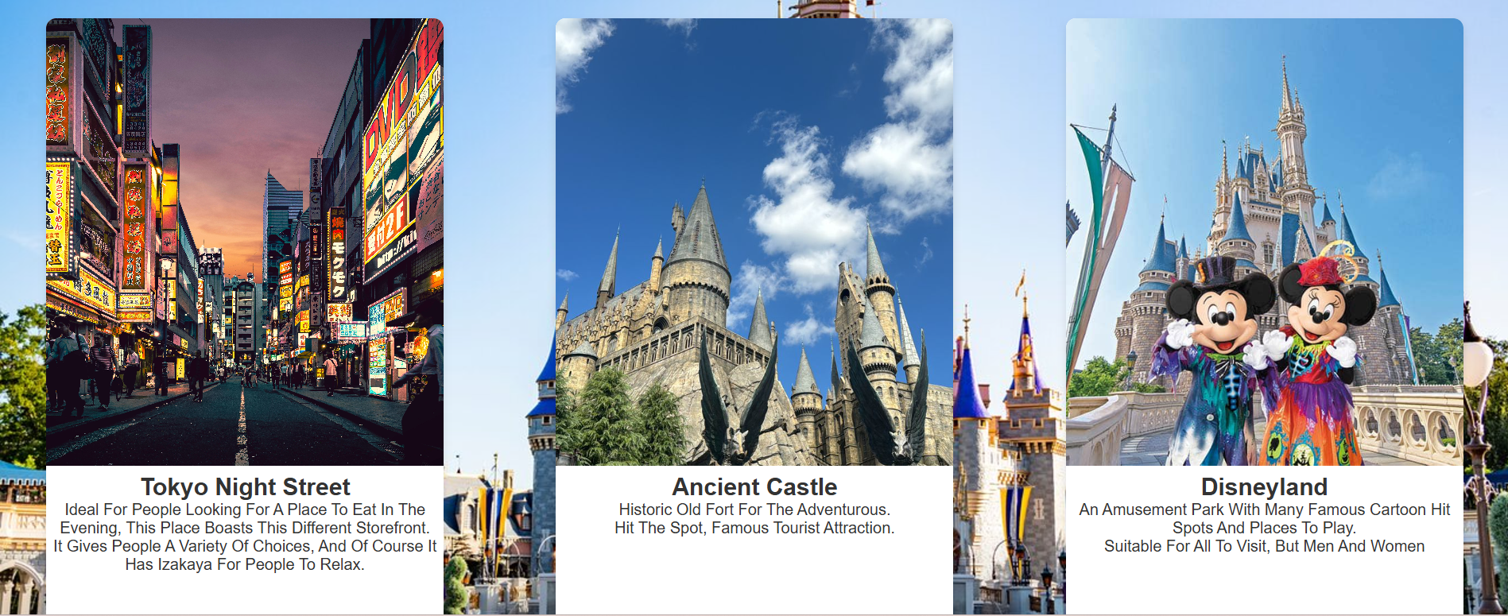

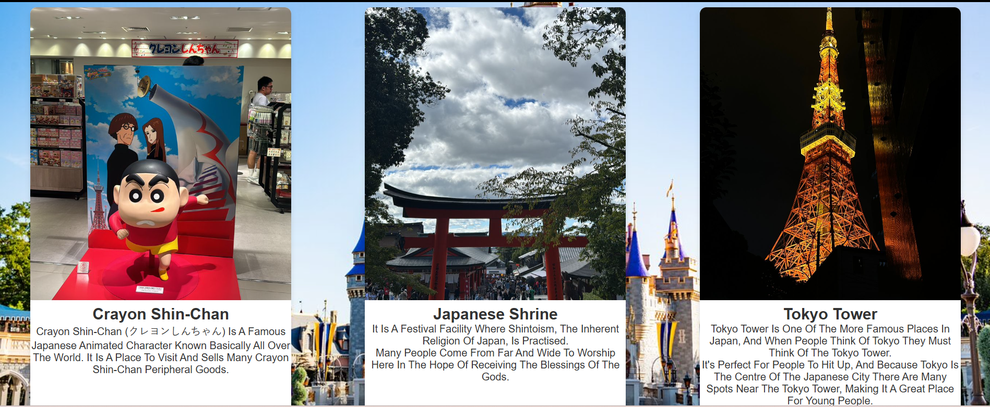

# Tourism and Packages Page

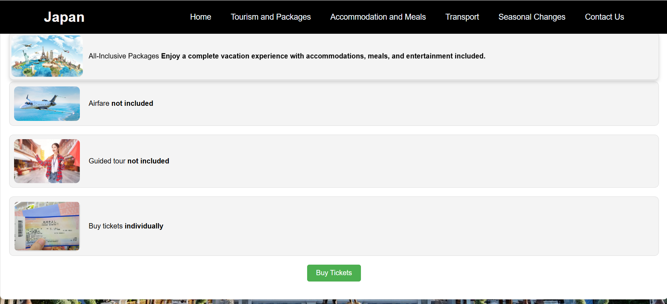

# 

# Accommodation and Meals

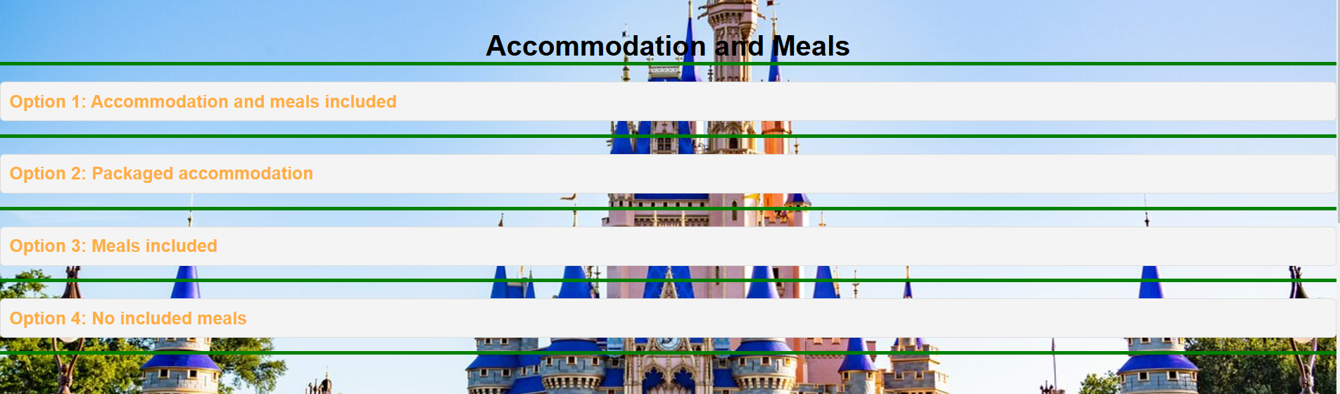

# Transport

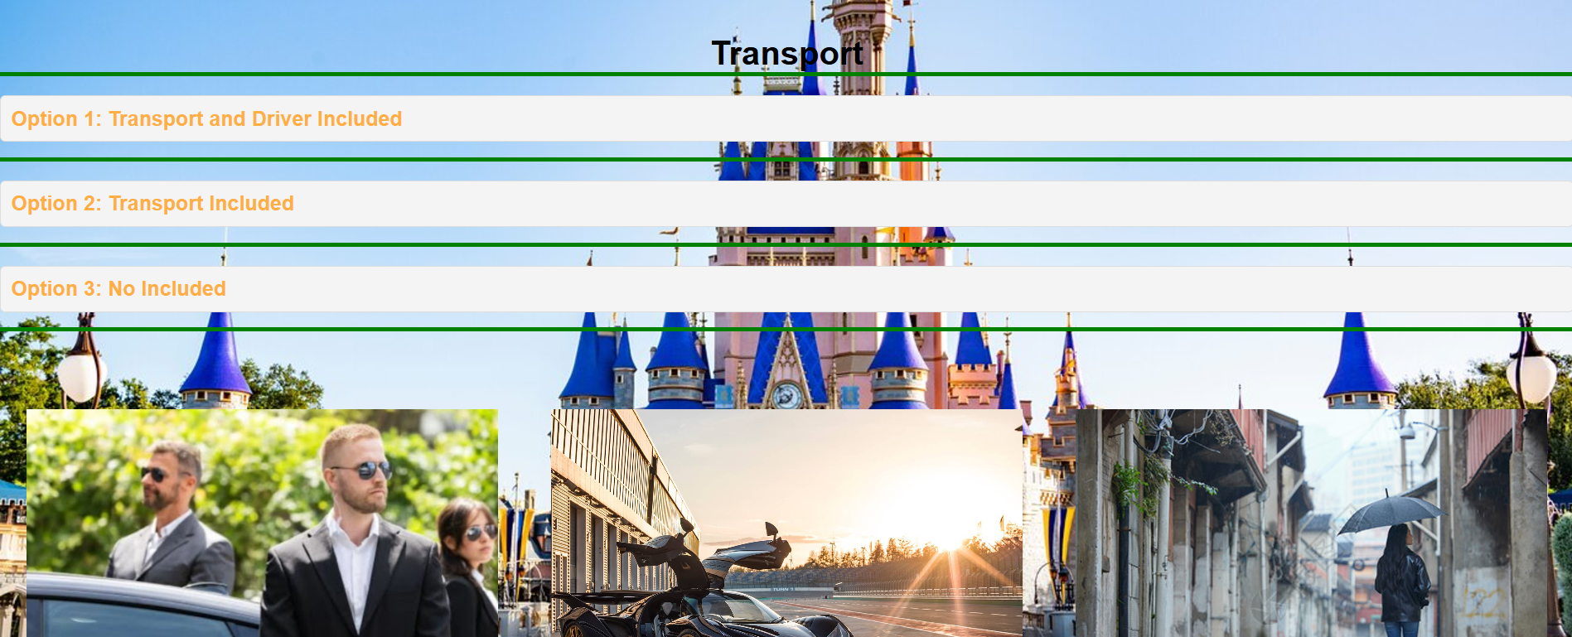

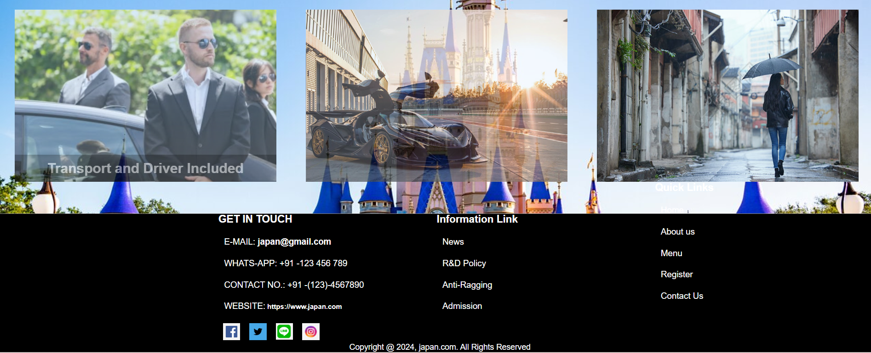

# Seasonal Changes

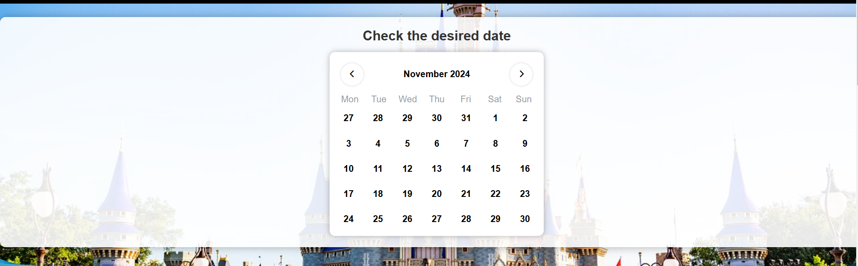

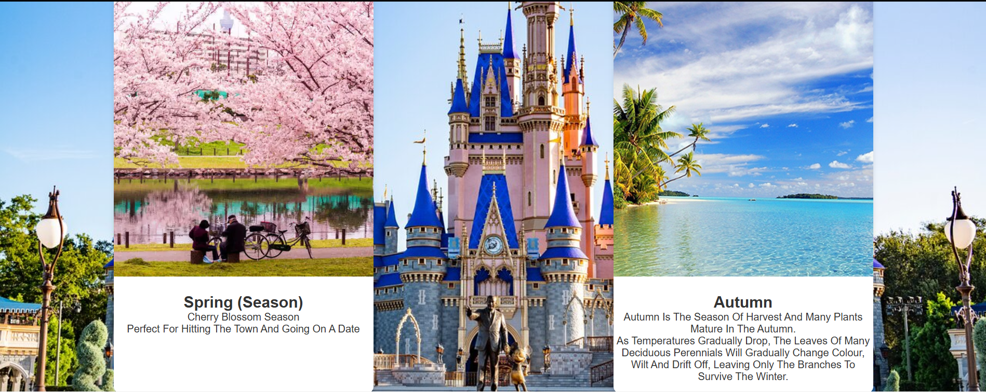

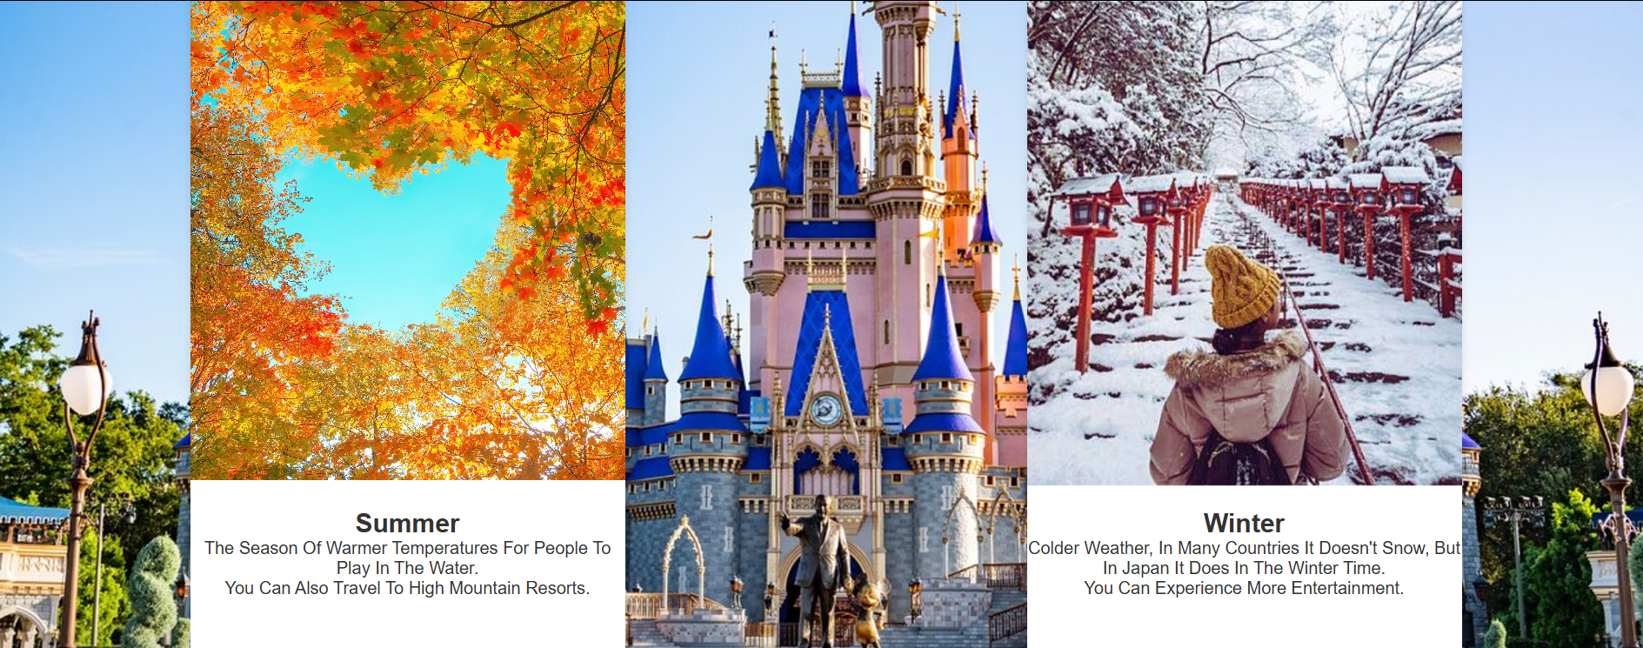

# Content Us

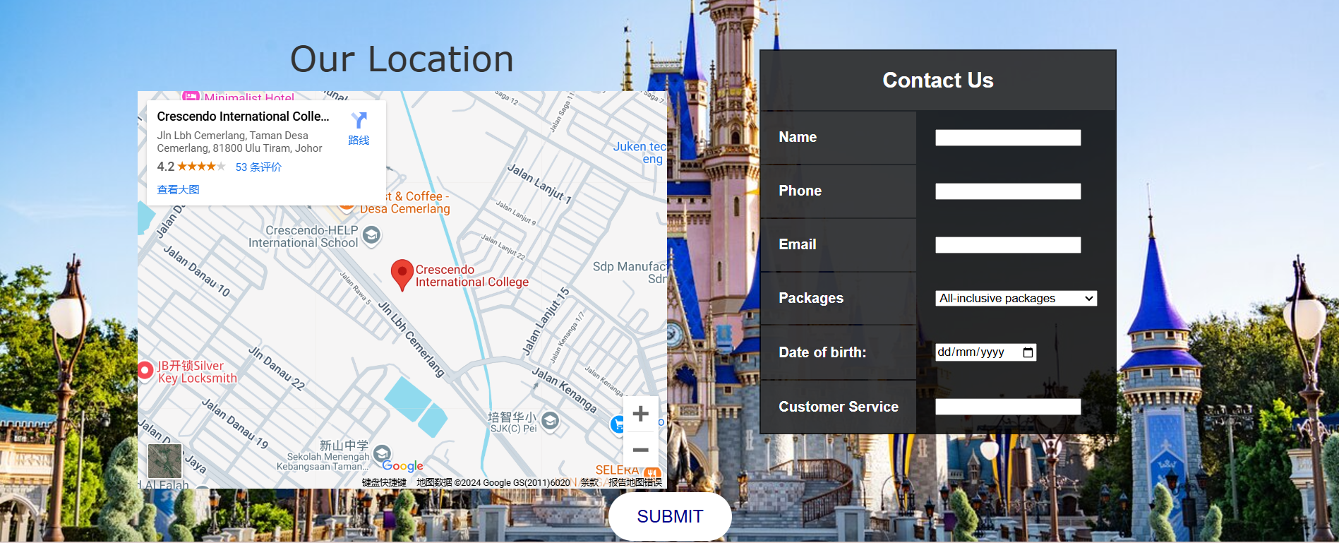

# Conclusion

This site gives people who want to go to Japan a quick idea of what the country has to offer in terms of attractions and features. Users can also find information from the site if they want to know about some of the seasonal changes in Japan. Then if the user wants to choose a package, there are many packages that are passed through the website for the user to choose from. If the user has any enquiry, they can also contact us to find out the information they want.

# Reference List

www.merriam-webster.com. (n.d.). *Definition of DRIVER*. [online] Available at: <https://www.merriam-webster.com/dictionary/driver>.

‌

Tripadvisor. (2023). *Langkawi*. [online] Available at: <https://www.tripadvisor.com.my/HotelsList-Malaysia-All-Inclusive-Hotels-zfp5756409>.html [Accessed 23 Nov. 2024].

‌

Japan National Tourism Organization (JNTO). (n.d.). *Welcome to the Japan National Tourism Organization Website*. [online] Available at: <https://www.japan.travel/en/my/>.

‌

Japan Guide (2019). *japan-guide.com - Japan Travel and Living Guide*. [online] Japan-guide.com. Available at: <https://www.japan-guide.com/>.

‌

JapanTravel. (2019). *Japan Travel - Japan Tourism Guide and Travel Map*. [online] Available at: <https://en.japantravel.com/>.

‌

JapanGov - The Government of Japan. (n.d.). *Visiting Japan | The Government of Japan - JapanGov -*. [online] Available at: <https://www.japan.go.jp/japan/visit/index.html>.

‌

W3Schools (n.d.). *CSS Tutorial*. [online] W3schools.com. Available at: <https://www.w3schools.com/css/default.asp>.

‌

w3Schools (2019). *JavaScript Tutorial*. [online] W3schools. Available at: <https://www.w3schools.com/js/default.asp>.

‌

W3Schools (2022). *HTML Tutorial*. [online] W3schools.com. Available at: <https://www.w3schools.com/html/default.asp>.

‌

## Grading Sheet

Your individual project will be assessed against the following criteria for various assessment purposes.

|  |  |  |  |  |  |  |  |
| --- | --- | --- | --- | --- | --- | --- | --- |
| **No.** | **Criteria** | **Rubrics / Marks** | | | | | **Mark Achieved** |
| **2 – Not Yet Meet Expectation** | **4 – Approaching Expectation** | **6 – Acceptable** | **8 – Good** | **10 – Exceeding Expectation** |
| **1.** | **Level of Understanding** | No understanding of the question or problem | Some understanding of the question or problem | Basic understanding of the question or problem | Good understanding of the question or problem | Full and complete understanding of the question or problem |  |
| **2.** | **Accurate and relevant to the topics of discussion** | Parts of the project incomplete and/or problem not identified properly. | Problem briefly defined and related questions briefly answered. Could be more complete. | Problem adequately defined. Related questions adequately answered. | Problem is completely defined and answers to related questions. | Problem is completely defined and answers to related questions and demonstrated extra effort. |  |
| **3.** | **Arguments are supported with evidences** | Did not recognize what evidences were needed. | Recognized some of the evidences needed. | Recognized most of the critical information and evidences needed to develop the arguments. | Recognized all the critical information and evidences still needed to develop a plan. | All critical information had been included and demonstrated extra effort that exceeded the expectations. |  |
| **4.** | **Clear argumentations and justifiable/supp orted viewpoints** | Argumentations were inadequate, and not justifiable. Introduction and conclusion are missing. | Argumentations were somewhat justifiable and reasonable.  Unclear/unrelate d intro & conclusion. | Argumentations were mostly justifiable and reasonable.  Unfocused intro & conclusion. | Argumentations were completely justifiable and reasonable. Good Intro & conclusion. | Arguments were justified and reasonable, exceeding the expectations.  Good & concise intro & conclusion. |  |

|  |  |  |  |  |  |  |  |
| --- | --- | --- | --- | --- | --- | --- | --- |
| **No.** | **Criteria** | **Rubrics / Marks** | | | | | **Mark Achieved** |
| **2 – Not Yet Meet Expectation** | **4 – Approaching Expectation** | **6 – Acceptable** | **8 – Good** | **10 – Exceeding Expectation** |
| **5.** | **Clear and logical development of viewpoints.** | Ideas developed were irrelevant, and confusing. | Ideas do not easily flow from one paragraph to another. There is no logical sequence in the placement of the paragraphs. | Some ideas do not flow to the next paragraph.  Occasionally lacks a logical sentence sequence. | Ideas flow from one paragraph to another. There is a logical sequence and explanations are clear. | Ideas flow smoothly from one paragraph to another. Ideas are developed cogently, organized logically and are connected with effective transitions. |  |
| **6.** | **Use of accurate terminology** | The use of accurate terminology is not present in the response | The use of accurate terminology is may be present in the response | The use of accurate terminology is present in the response | The use of accurate terminology is mostly present in the response | The use of accurate terminology enhance the response |  |
| **7.** | **Sources to be clearly in-text cited and efficiently used.** | Works cited from non- credible/fabricate d resources. | References are improperly or incorrectly cited. | Only some references are properly cited. Works cited follows some of the rules of Harvard Referencing format. | Most references are properly cited. Works cited follows most of the rules of Harvard Referencing format. | Each reference is properly cited both within the text and follows exactly the rules of Harvard Referencing format. |  |

|  |  |  |  |  |  |  |  |
| --- | --- | --- | --- | --- | --- | --- | --- |
| **No.** | **Criteria** | **Rubrics / Marks** | | | | | **Mark Achieved** |
| **2 – Not Yet Meet Expectation** | **4 – Approaching Expectation** | **6 – Acceptable** | **8 – Good** | **10 – Exceeding Expectation** |
| **8.** | **Reference list is available and in correct format and structure.** | Incomplete and incorrectly formatted. Number of sources required not adhered to. | Included with lots of mistakes, and/or a partial reference is included but not correctly formatted. The proper amount of resources were used. | Included with some mistakes, and/or a partial references is included and correctly formatted. The proper amount of resources were used. | Included, properly formatted, and proper number of different resource types were used. | Error free, and exceeded the expected amount of resources. |  |
| **9.** | **Correct usage of sentence structure, grammar, spelling, and punctuations.** | Spelling and Grammar mistakes impedes with the reading and understanding of the paper. | A great deal of spelling and grammar mistakes distracts the reader. | Some grammar and spelling mistakes are made. | Final draft is clearly edited. All Grammar and Spelling is used correctly, few or no mistakes are made. | Final draft is completely error free and exceeded the expectations. |  |
| **10.** | **Correct usage of formatting – font size, spacing, margin, and title headings.** | Font, spacing and margin sizes are consistently incorrect. Title is missing. | An attempt at correct font and margin size was made. | Font size is correct. Title is present but not in proper format. | Final draft is clearly edited.  Font sizes are correct throughout the paper. Title is present and in proper format. | Final draft is completely error free and exceeded the expectations. |  |
| **TOTAL MARKS (100%)** | | | | | | |  |
| **WEIGHTAGE (20%)** | | | | | | |  |